## Reports/ Rx Reports/ DUR Override Summary

Request:

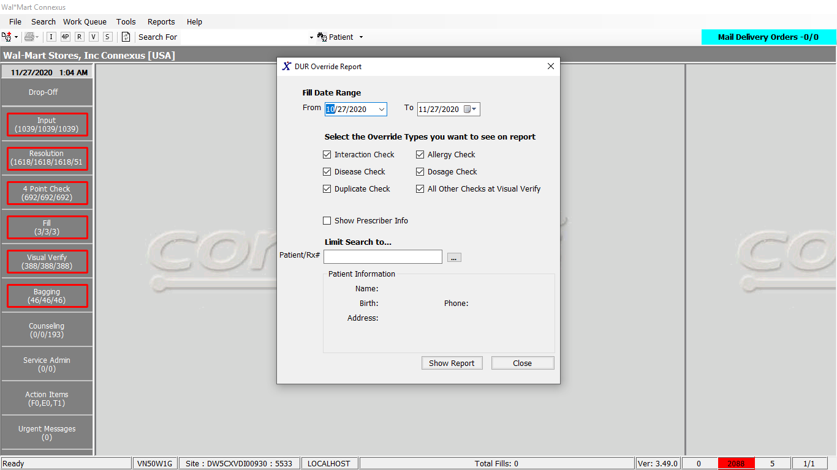

Response:

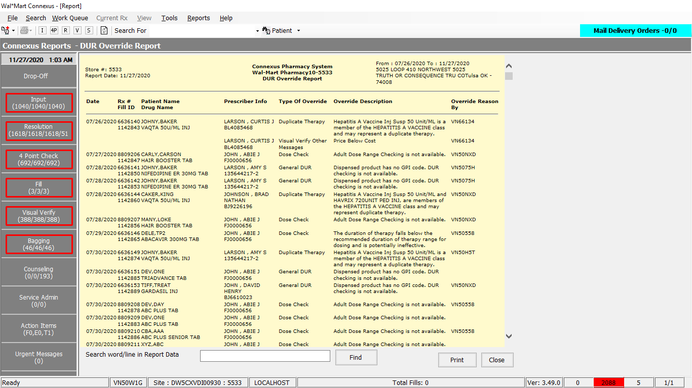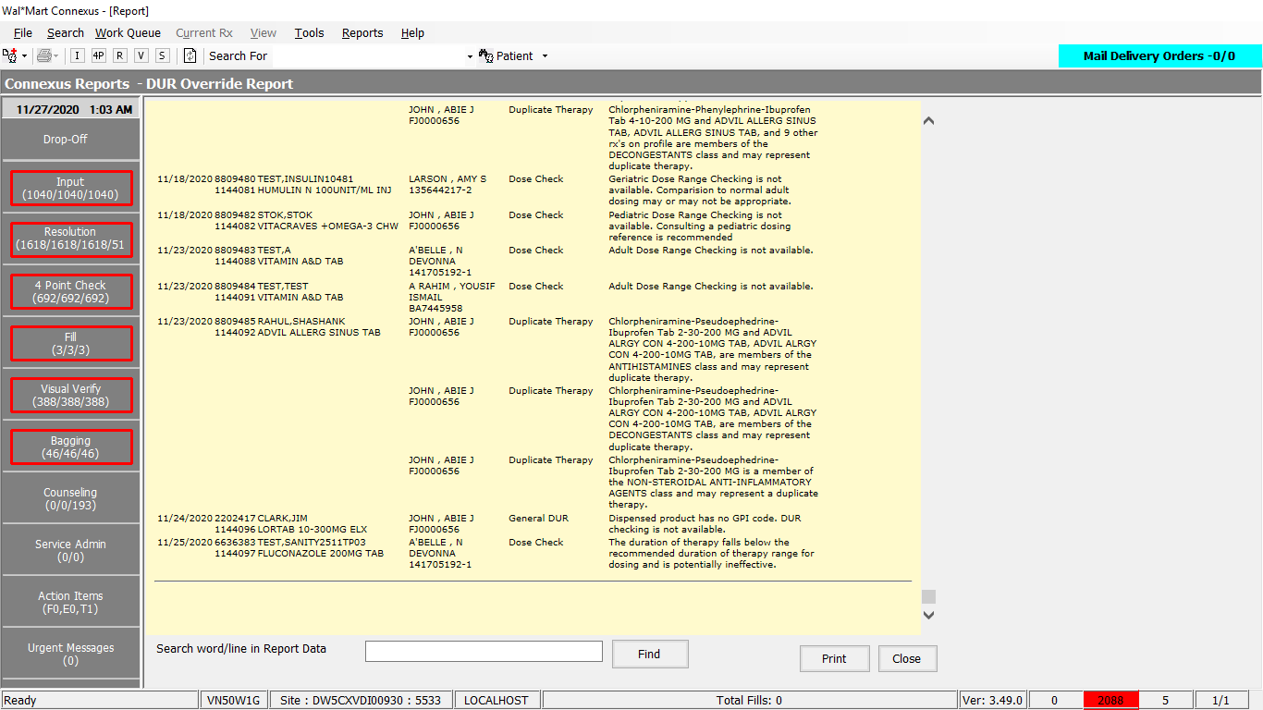

Queries:

1. Friend Const GetDurOverrideDataSelectPart1 As String = "SELECT distinct rx.rx_id, rx.rx_version_seq_nbr, rf.rx_fill_id, rf.fill_date, rx.rx_nbr, TRIM(NVL(pa.last_name,'')) || ',' || TRIM(NVL(pa.first_name,'')) || ' ' || TRIM(NVL(pa.middle_name,'')) PatientName, pp.short_name, pct.code_desc override_type, rxc.conflict_msg_txt, rxc.resolution_userid, pr.last_name || ', ' || pr.first_name || ' ' || pr.middle_name pres_name,NVL(rpl.license_nbr,pl.license_nbr) DEA, sc1.communication_id pres_phone "

2. Friend Const GetDurOverrideDataSelectPart2 As String = " , CASE WHEN rxc.dur_reason_code = 7 THEN ( SELECT cl.comment_text FROM comment_line cl,conflict_comment cc WHERE cl.comment_id=cc.comment_id AND cc.conflict_seq_nbr=rxc.conflict_seq_nbr AND cc.rx_id=rxc.rx_id AND rxc.comment_ind = 'Y') ELSE (SELECT drt.dur_reason_desc FROM dur_reason_txt drt, phm_problem_dur_rsn ppd WHERE drt.dur_reason_code=ppd.dur_reason_code AND drt.dur_reason_code=rxc.dur_reason_code AND ppd.phm_problem_code=rxc.phm_problem_code) End Reason "

3. Friend Const GetDurOverrideDataSelectPart3 As String = " FROM rx, rx_conflict rxc, pharmacy_code_txt pct, pharmacy_offering:pharmacy_product pp, rx_fill rf, rx_fill_item rfi, pharmacy_offering:pharmacy_item pi, patient pa, prescriber pr, prescriber_clinic pcli, OUTER subject_comm sc1, OUTER prescriber_license pl, OUTER rx_prsbr_license rpl WHERE rx.rx_id = rxc.rx_id AND rxc.conflict_type_code = pct.code_id AND rx.patient_id = pa.patient_id AND rx.prescriber_id = pr.prescriber_id AND pr.prescriber_id = pl.prescriber_id AND pl.license_seq_nbr = (SELECT MIN(license_seq_nbr) FROM prescriber_license pl1 WHERE pl1.prescriber_id = pl.prescriber_id AND (pl1.expiration_date IS NULL OR pl1.expiration_date >= TODAY) AND (pl1.effective_date is NULL OR pl1.effective_date <= TODAY)) AND rpl.rx_id = rx.rx_id AND rpl.prescriber_id = rx.prescriber_id AND rpl.license_type_code = 800 AND (((SELECT count(rfa1.activity_code) FROM rx_fill_activity rfa1 WHERE rfa1.rx_fill_id = rf.rx_fill_id AND rfa1.activity_code = 15116) > 0 AND rpl.license_nbr like 'X%') OR ((SELECT count(rfa2.activity_code) FROM rx_fill_activity rfa2 WHERE rfa2.rx_fill_id = rf.rx_fill_id AND rfa2.activity_code = 15115) > 0 AND rpl.license_nbr not like 'X%') OR ((SELECT count(rfa2.activity_code) FROM rx_fill_activity rfa2 WHERE rfa2.rx_fill_id = rf.rx_fill_id AND rfa2.activity_code in (15115,15116)) = 0)) AND pcli.primary_clinic_ind = 'Y' AND pcli.clinic_id = sc1.subject_id AND pr.prescriber_id = pcli.prescriber_id AND sc1.subject_type_code = 303 AND sc1.comm_method_code = 2 AND sc1.comm_seq_nbr = 2 AND rx.rx_id = rf.rx_id AND rx.rx_version_seq_nbr = rf.rx_version_seq_nbr AND rf.rx_fill_id = rxc.current_rx_fill_id AND rfi.rx_fill_id = rf.rx_fill_id AND rfi.item_mds_fam_id = pi.mds_fam_id AND pi.product_mds_fam_id = pp.product_mds_fam_id AND rxc.conflict_type_code IN ("

4. Public Const GetDateTime As String = "Select CURRENT dtmCurrent FROM systables where tabname = 'systables'"

DAL:

Public Function GetDurOverrideData(ByVal siteId As Integer,

Optional ByVal getDurOverrideDataInputInfo As _

GetDurOverrideDataInputInfoBE = Nothing) _

As List(Of GetDurOverrideDataInfoBE) Implements IReportDAL.GetDurOverrideData

Using (New Tracer(ConnexusCommonConstants.ConnexusTracer))

Dim sqlString As New StringBuilder

Dim DUR As New StringBuilder

Dim getDUROverrideDataInfoBEList As New List(Of GetDurOverrideDataInfoBE)

Dim paramList As New List(Of DbParameter)

If getDurOverrideDataInputInfo.Interaction Then

DUR.Append(CStr(DURConflict.CrossCheck).Trim)

Else

DUR.Append("0")

End If

'QA40: Added by - Infosys for LR - Rx Origin

Dim result As String

result = ReportDAL.GetBUPhmParm(siteId, ServicesCommonConstants.CheckDurOn)

'QA40: End by - Infosys for LR - Rx Origin

If getDurOverrideDataInputInfo.Allergy Then

DUR.Append("," & DURConflict.AllergyCheck)

End If

If getDurOverrideDataInputInfo.Disease Then

DUR.Append("," & DURConflict.DrugDisease)

End If

If getDurOverrideDataInputInfo.Dosage Then

DUR.Append("," & DURConflict.DoseCheck)

End If

If getDurOverrideDataInputInfo.Duplicate Then

DUR.Append("," & DURConflict.DuplicateTherapy)

End If

If getDurOverrideDataInputInfo.Other Then

DUR.Append("," & DURConflict.GeneralDUR & ",")

DUR.Append(DURConflict.GPIInterchange & "," & DURConflict.MedicationCrossCheck & ",")

DUR.Append(DURConflict.VisualVerifyOtherMessages)

End If

sqlString.Append(ReportQueries.GetDurOverrideDataSelectPart1)

'QA40: Added by akavoor- Infosys for LR - Log DUR

If result.Trim().ToUpper(CultureInfo.InvariantCulture) = "TRUE" Then

sqlString.Append(ReportQueries.GetDurOverrideDataSelectPart2)

End If

'End

sqlString.Append(ReportQueries.GetDurOverrideDataSelectPart3)

sqlString.Append(DUR)

sqlString.Append(")")

sqlString.Append(" AND rf.fill_date >= ? ")

sqlString.Append(" AND rf.fill_date <= ? ")

paramList.AddParameter(DbType.Date, getDurOverrideDataInputInfo.StartFillDate, "fillDate")

paramList.AddParameter(DbType.Date, getDurOverrideDataInputInfo.EndFillDate, "fillDate")

If getDurOverrideDataInputInfo.RxNbr > 0 Then

sqlString.Append(" AND rx.rx_nbr = ? ")

paramList.AddParameter(DbType.Int32, getDurOverrideDataInputInfo.RxNbr, "rxNbr")

ElseIf getDurOverrideDataInputInfo.PatientId > 0 Then

sqlString.Append(" AND pa.patient_id = ? ")

paramList.AddParameter(DbType.Int32, getDurOverrideDataInputInfo.PatientId, "patientId")

End If

If getDurOverrideDataInputInfo.Sort.Equals("F") Then

sqlString.Append(" ORDER BY rf.fill_date, rx_nbr, rf.rx_fill_id ")

Else

sqlString.Append(" ORDER BY pp.short_name")

End If

Dim dataReader As IDataReader = ExecuteReader(DatabaseEnum.rx21c, siteId,

sqlString.ToString, paramList)

Dim getDUROverrideDataBE As GetDurOverrideDataInfoBE

While dataReader.Read

getDUROverrideDataBE = New GetDurOverrideDataInfoBE

getDUROverrideDataBE.CodeDesc = dataReader.GetValueOrDefault(Of String)("override_type").SafeTrim()

getDUROverrideDataBE.ConflictMsgTxt = dataReader.GetValueOrDefault(Of String)("conflict_msg_txt").SafeTrim()

getDUROverrideDataBE.FillDate = dataReader.GetValueOrDefault(Of Date)("fill_date")

getDUROverrideDataBE.LicenseNbr = dataReader.GetValueOrDefault(Of String)("DEA").SafeTrim()

If getDUROverrideDataBE.LicenseNbr IsNot Nothing Then

If getDUROverrideDataBE.LicenseNbr.Length > ServicesCommonConstants.PrescriberDEALength AndAlso Not getDUROverrideDataBE.LicenseNbr.Contains("-") Then

getDUROverrideDataBE.LicenseNbr = getDUROverrideDataBE.LicenseNbr.Substring(0, ServicesCommonConstants.PrescriberDEALength) & "-" & getDUROverrideDataBE.LicenseNbr.Substring(ServicesCommonConstants.PrescriberDEALength)

End If

End If

getDUROverrideDataBE.PatientName = dataReader.GetValueOrDefault(Of String)("PatientName").SafeTrim()

getDUROverrideDataBE.PresName = dataReader.GetValueOrDefault(Of String)("pres_name").SafeTrim()

getDUROverrideDataBE.PresPhone = dataReader.GetValueOrDefault(Of String)("pres_phone").SafeTrim()

getDUROverrideDataBE.ResolutionUserId = dataReader.GetValueOrDefault(Of String)("resolution_userid").SafeTrim()

getDUROverrideDataBE.RxFillId = dataReader.GetValueOrDefault(Of Int32)("rx_fill_id")

getDUROverrideDataBE.RxId = dataReader.GetValueOrDefault(Of Int32)("rx_id")

getDUROverrideDataBE.RxNbr = dataReader.GetValueOrDefault(Of Int32)("rx_nbr")

getDUROverrideDataBE.RxVersionSeqNbr = dataReader.GetValueOrDefault(Of Int16)("rx_version_seq_nbr")

getDUROverrideDataBE.ShortName = dataReader.GetValueOrDefault(Of String)("short_name").SafeTrim()

If result.Trim().ToUpper(CultureInfo.InvariantCulture) = "TRUE" Then

getDUROverrideDataBE.Reason = dataReader.GetValueOrDefault(Of String)("reason").SafeTrim()

End If

getDUROverrideDataInfoBEList.Add(getDUROverrideDataBE)

End While

If getDUROverrideDataInfoBEList.Count > 0 Then

Return getDUROverrideDataInfoBEList

Else

Return Nothing

End If

End Using

End Function

Public Shared ReadOnly Property GetDBDateTime(ByVal siteId As Integer) As DateTime

Get

Using (New Tracer(ConnexusCommonConstants.ConnexusTracer))

Dim dbDateTime As DateTime

Dim offset As TimeSpan

Dim isOffsetValid As Boolean

'Get the offset time from cache

isOffsetValid = TimeSpan.TryParse(Convert.ToString(CnxCache(CStr(CacheKeys.OffsetTime))), offset)

If (Not isOffsetValid) Then

'get it from db

'execute query

dbDateTime = CDate(ExecuteScalar(DatabaseEnum.rx21c, siteId, BaseQueries.GetDateTime))

offset = dbDateTime.Subtract(DateTime.Now)

'Add it to Cache

CnxCache.Add(CStr(CacheKeys.OffsetTime), offset, CacheHelper.GetExpirationPolicy(CStr(CacheKeys.OffsetTime)))

End If

Return DateTime.Now.Add(offset)

End Using

End Get

End Property